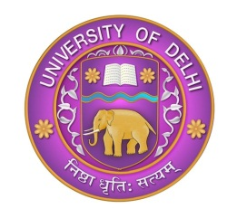 | UNIVERSITY OF DELHI  DELHI – 110007

No. Aca.I/COVID-19/Online Education
14th May, 2020

NOTICE

In order to address the requirements of the students in terms of better comprehension, doubt clearance, queries with regard to the syllabus, as well as conceptual clarity on specific topics of subjects of their study, all the stakeholders in the Departments and Colleges of the University are advised to conduct special webinars, special online lectures, doubt clearance sessions, special sessions for a period of 3 days with effect from 15.05.2020 positively to help the students, both at the undergraduate and postgraduate level, as a follow up of the online teaching-learning process conducted during the lockdown period. The internal assessment and other activities as per notification of the Dean Examinations dated 13.05.2020 can be initiated following the 3 days of Special Review / Revision Sessions.

All the stakeholders including the Deans of the Faculties, Heads of the Departments and the Principals of the Colleges are requested to give adequate publicity of this facility being created for the benefit of the students, through website, e-mails and other viable modes of online communications, to supplement already conducted online teaching-learning in all these days. All the stakeholders are requested to ensure optimum utilization of this facility by the students.

This issue with direction of the Competent Authority.

REGISTRAR (ACTING)

